Housing Prices in Metropolitan Areas of India

**1.Introduction:**

House price prediction in a metropolitan city in India is a valuable solution for potential home buyers, real estate agents, and investors. By leveraging historical sales data, property details, and location-specific information, a predictive model can accurately estimate house prices. The model's scalability, real-time updates, user-friendly interface, and transparency ensure it meets the needs of stakeholders. Integration capability, data privacy, and cost-effectiveness are also important considerations. By addressing these requirements, the prediction model provides reliable insights, empowering stakeholders to make informed decisions in the fast-paced real estate market.

# 2.Define Problem / Problem Understanding

2.1. Empathy Map:

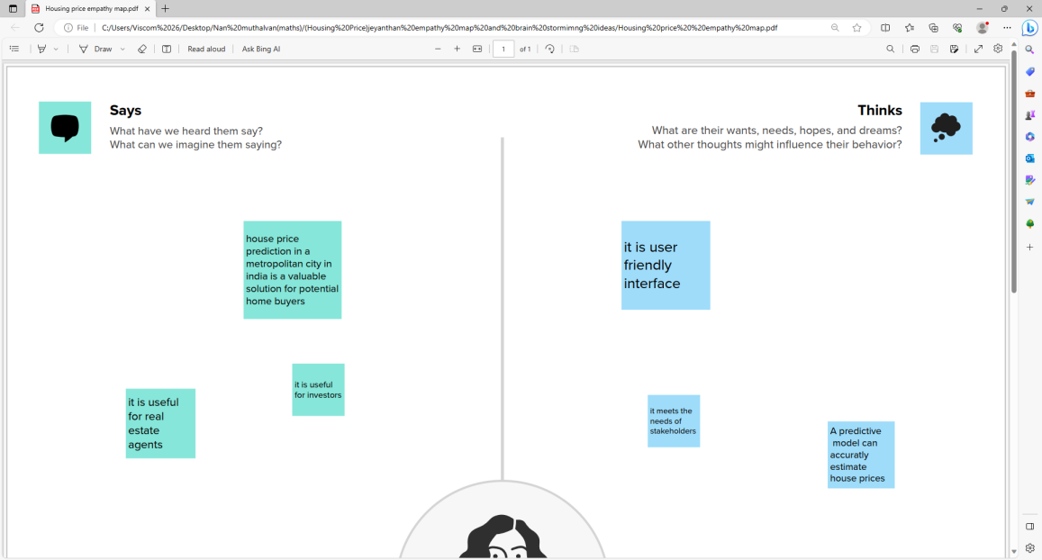

2.2. Brainstorming Ideas:

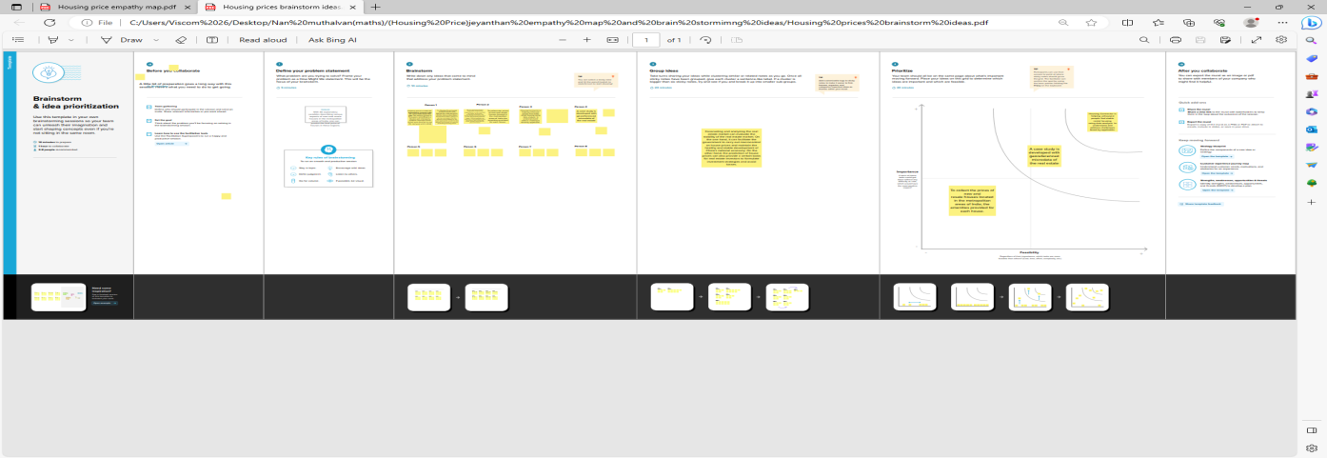

## Advantages & Disadvantages:

The business problem at hand is the prediction of house prices in a metropolitan city in India. The real estate market in such cities is complex and dynamic, making it challenging for potential home buyers, real estate agents, and investors to accurately estimate property values. By developing a predictive model using relevant datasets and features, stakeholders can gain insights into the factors influencing house prices and make informed decisions regarding property investments. The goal is to provide a reliable and accurate prediction tool that assists users in navigating the competitive real estate market and maximizing their returns.

The business requirements for house price prediction in a metropolitan city in India include developing an accurate prediction model that can estimate property prices. The model should identify the key features impacting house prices and provide insights to aid decision-making. It should be scalable to handle a large volume of data and incorporate real-time updates to reflect the latest market conditions. The solution should have a user-friendly interface, ensure transparency and explain ability of predictions, prioritize data privacy and security, and define performance metrics for evaluation. Integration capability and cost-effectiveness are also important considerations to deliver a valuable and efficient solution.

**Conclusion:**

Conclusion and Recommendations The Indian economy is passing through a transition from a low growth economy to a high growth economy. The government is encouraging the housing sector which is inter-linked with nearly three hundred industries in the country. The housing sector also has strong linkage with credit market and banking institutions. The monetary policy also has a two-way relationship with the housing sector. Housing price indices play an important role in understanding the price movement of housing as well as general trend of growth in the country. To understand about house prices, it is important to understand about housing indices. These indices need to be publicly provided and accurately calculated to help understand the underlying asset. In India, NHB and RBI construct and release an index each, RESIDEX and HPI, respectively. In case of both the indices there are a number of problems. Illustratively, RESIDEX is based on extensive data collected by different commercial banks and finance company located in 26 cities and is widely accepted in the country. Innovations that rely on data sources cannot be implemented until precise indices are provided in public domain and with robust history to inspire confidence. In India, neither data definitions are standardized nor is the methodology.